2020
Test Driven Development
Hamid Mujtaba

Contents
Test Driven Development 3
Pros vs Cons 3
References 5

Test Driven Development
Test driven development is a style of programming where developers create test cases for every functionality of the program to ensure the code runs as expected. They refactor/change the code if the automated test fails and improve the code until the test passes, which also helps avoid duplication of code.
Test driven development is an implementation cycle with 5 main steps.
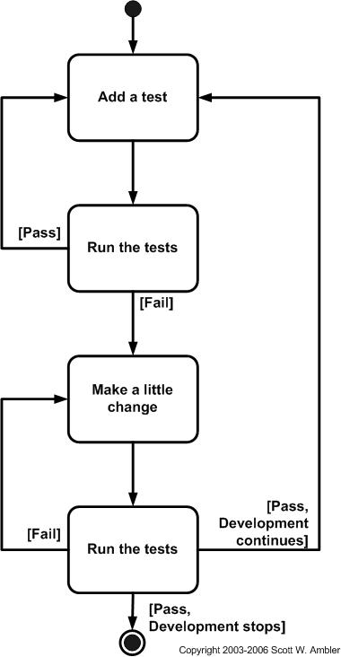
- The first step is to understand what the function requirements are and then add a test which defines the function.
- The second step is to run the tests to see if new tests fail. The tests are expected to fail as there is no code that has been implemented yet.
- The third step is to write and implement code which meet the requirements so that the tests pass.
- Fourth step is to run the tests again to see if they pass or not. If it passes, you move to the first step and add a new test. However, if the tests fail, you go back to step 3 to refactor the code and run the tests again; you repeat step 3 and 4 until the tests pass.
- Step is to repeat this process for each functionality until all your tests pass and your software meets all the requirements

Over the last couple of years, test driven development has gained a lot of popularity, however after a lot of programmers trying and failing to successfully make use of it, they concluded “TDD is not worth the effort it requires” (Andrea Koutifaris, 2018). Some of them thought that, although it may be a good practice in theory, it is too time consuming as there is never enough time to use test driven development, and few of them even agreed it is a waste of time. Some even argue that TTD focuses on passing tests, and not necessarily the correctness of code.

Pros vs Cons
There are pros and cons for using test driven development. One of the benefits of test-driven development is that it allows the code to be easily maintained and refactor. It makes it easier for others to edit your code because the tests would inform them if the changes made are causing the tests to fail. This allows collaboration between team members easier. Another benefit is that it makes debugging a lot easier. It can also be proved to be very useful in the long term as it is faster. For example, if you are trying to refactor some code you have written couple of years ago, it will prove to be very difficult; however, if you have already set up good suite of unit tests, it will be a lot easier and efficient.
Some of the cons of test-driven development is that it can be difficult to learn, so there is a difference between executing it and executing it well. Test driven development is also known to be initially slower as it is very time consuming.

Applying Test-driven Development
A test-driven development approach was used to develop an algorithm in Haskell programming language.

Reflections

References

Andrea koutifaris. 2018. Test Driven Development: what it is, and what it is not. [Online]. [25 May 2021]. Available from: https://www.freecodecamp.org/news/test-driven-development-what-it-is-and-what-it-is-not-41fa6bca02a2/

